Monthly Coverage Dossier

October 2020

Future Generali India Life Insurance Company Limited

No | Overview of Activities | Key Publications
1 | Authored article  Changing paradigms in performance management and productivity_ Ruchira Bhardwaja  Weaving back the threads_ Ruchira Bhardwaja  Marketing mantras in COVID times_ Rakesh Wadhwa  Real estate usuage can be optimised post pandemic_ S. Mahesh  Video based identification process (VBIP) heralds a quatam shift in customer verification & KYC processes_ S. Mahesh | - NavGujarat Samay  - Andhra Prabha  - NavGujarat Samay  - Dina Kural  - Aaj  - Dinakhatir  - Express Computers
2 | Interview  With the pandemic, customers prefer guaranteed savings plans over ULIPs: Rakesh Wadhwa | - Adgully
3 | Press release  FGILI introduces Future Generali new assured wealth plan_ Rakesh Wadhwa | - UNI  - Financial Express
4 | Industry story  RBI Monetary Policy_ Ms. Jyoti Vaswani  Defining a marketing genius_ Rakesh Wadhwa | - The Financial Express  - Banking Frontiers

INDEX
No | Publication | Headline | Date | Coverage appeared
Authored article
1 | NavGujarat Samay | Changing paradigms in performance management and productivity_ Ruchira Bhardwaja | 1st Oct 2020 | Print
2 | Prabhat | Changing paradigms in performance management and productivity_ Ruchira Bhardwaja | 1st Oct 2020 | Print
3 | Standard Herald | Changing paradigms in performance management and productivity_ Ruchira Bhardwaja | 1st Oct 2020 | Print
4 | Divya Gujarat | Changing paradigms in performance management and productivity_ Ruchira Bhardwaja | 1st Oct 2020 | Print
5 | NavGujarat Samay | Weaving back the threads_ Ruchira Bhardwaja | 7th Oct 2020 | Print
6 | Prabhat | Weaving back the threads_ Ruchira Bhardwaja | 7th Oct 2020 | Print
7 | Standard Herald | Weaving back the threads_ Ruchira Bhardwaja | 7th Oct 2020 | Print
8 | Newsline Sidha Samachar | Weaving back the threads_ Ruchira Bhardwaja | 7th Oct 2020 | Print
9 | Dinakural | Weaving back the threads_ Ruchira Bhardwaja | 29th Oct 2020 | Print
10 | Southern Mail | Weaving back the threads_ Ruchira Bhardwaja | 29th Oct 2020 | Print
11 | Aaj | Marketing mantras in COVID times_ Rakesh Wadhwa | 6th Oct 2020 | Print
12 | Dinakhtir | Real estate usuage can be optimised post pandemic_ S. Mahesh | 8th Oct 2020 | Print
13 | Surya | Changing paradigms in performance management and productivity_ Ruchira Bhardwaja | 19th Oct 2020 | Print
14 | Andhra Prabha | Changing paradigms in performance management and productivity_ Ruchira Bhardwaja | 19th Oct 2020 | Print
15 | Adab Hyderabad | Changing paradigms in performance management and productivity_ Ruchira Bhardwaja | 19th Oct 2020 | Print
16 | Business Bytes | Changing paradigms in performance management and productivity_ Ruchira Bhardwaja | 21st Oct 2020 | Online
17 | Express Computers | Video based identification process (VBIP) heralds a quatam shift in customer verification & KYC processes | 23rd Oct 2020 | Online
Interview
18 | Adgully | With the pandemic, customers prefer guaranteed savings plans over ULIPs: Rakesh Wadhwa | 19th Oct 2020 | Online
Press Release
West
19 | Navbharat | Future Generali launches New Assured Wealth Plan | 9th Oct 2020 | Print - Mumbai
20 | NavGujarat Samay | Future Generali launches New Assured Wealth Plan | 9th Oct 2020 | Print - Ahmedabad
21 | Prabhat | Future Generali launches New Assured Wealth Plan | 9th Oct 2020 | Print - Ahmedabad
22 | Newsline Sidha Samachar | Future Generali launches New Assured Wealth Plan | 9th Oct 2020 | Print - Ahmedabad
23 | Standard Herald | Future Generali launches New Assured Wealth Plan | 9th Oct 2020 | Print - Ahmedabad
24 | ET Wealth | Product launch | 12th Oct 2020 | Print - Mumbai
25 | ET Wealth | Product launch | 12th Oct 2020 | Print - Ahmedabad
North
26 | ET Wealth | Product launch | 12th Oct 2020 | Print - Delhi
27 | Dainik Bhaskar | Future Generali launches New Assured Wealth Plan | 9th Oct 2020 | Print - Delhi
28 | Veer Arjun | Future Generali launches New Assured Wealth Plan | 9th Oct 2020 | Print - Delhi
29 | Rashtriya Sahara | Future Generali launches New Assured Wealth Plan | 9th Oct 2020 | Print - Lucknow
30 | Aaj Samaj | Announcement of the launch of the Future Generali assured wealth plan | 12th Oct 2020 | Print - Delhi
31 | Hukumnama Samachar | Future Generali launches New Assured Wealth Plan | 12th Oct 2020 | Print - Jaipur
32 | Dabang Dunia | Future Generali India Life Insurance Company Limited introduces Future Generali New Assured Wealth Plan | 12th Oct 2020 | Print - Delhi
33 | Aaj | Future Generali India Life Insurance Company Limited introduces Future Generali New Assured Wealth Plan | 14th Oct 2020 | Print - Lucknow
34 | Indian Horizon | Future Generali launches New Assured Wealth Plan | 12th Oct 2020 | Print - Delhi
35 | Dainik Navjyoti | Future Generali launches New Assured Wealth Plan | 20th Oct 2020 | Print - Jaipur
East
36 | ET Wealth | Product launch | 12th Oct 2020 | Print - Kolkata
37 | Echo of India | Future Generali launches New Assured Wealth Plan | 9th Oct 2020 | Print - Kolkata
38 | Arthik Lipi | Future Generali launches New Assured Wealth Plan | 9th Oct 2020 | Print - Kolkata
39 | Info India | Future Generali India Life Insurance Company Limited introduces Future Generali New Assured Wealth Plan | 12th Oct 2020 | Print - Kolkata
40 | Prabhu Rashtriya | Future Generali India Life Insurance Company Limited introduces Future Generali New Assured Wealth Plan | 16th Oct 2020 | Print - Kolkata
41 | Vishwamitra | Future Generali India Life Insurance Company Limited introduces Future Generali New Assured Wealth Plan | 23rd Oct 2020 | Print - Kolkata
South
42 | ET Wealth | Product launch | 12-Oct-20 | Print – Bangalore
43 | ET Wealth | Product launch | 12-Oct-20 | Print – Chennai
44 | ET Wealth | Product launch | 12-Oct-20 | Print – Hyderabad
45 | Adab Hyderabad | Future Generali launches New Assured Wealth Plan | 9th Oct 2020 | Print – Hyderabad
46 | Surya | Future Generali India Life Insurance introduces Future Generali New Assured Wealth Plan | 9th Oct 2020 | Print - Hyderabad
47 | Andhra Prabha | Future Generali New Assured Wealth Plan | 9th Oct 2020 | Print - Hyderabad
48 | Mana Telangana | Future Generali launches New Assured Wealth Plan | 9th Oct 2020 | Print - Hyderabad
49 | Sakshi | Future Generali launches New Assured Wealth Plan | 12th Oct 2020 | Print - Hyderabad
50 | The Hans India | New plan from Future Generali | 16th Oct 2020 | Print - Hyderabad
51 | Southern Mail | Future Generali India Life Insurance Company Limited introduces Future Generali New Assured Wealth Plan | 13th Oct 2020 | Print - Chennai
52 | Dinakural | Future Generali India Life Insurance introduces Future Generali New Assured Wealth Plan | 13th Oct 2020 | Print - Chennai
53 | Velli Idal | Future Generali India Life Insurance introduces Future Generali New Assured Wealth Plan | 13th Oct 2020 | Print - Chennai
54 | Dinakathir | Future Generali India Life Insurance introduces Future Generali New Assured Wealth Plan | 13th Oct 2020 | Print - Chennai
55 | Virtual Times | Future Generali India Life Insurance Company Limited introduces Future Generali New Assured Wealth Plan | 14th Oct 2020 | Print - Chennai
56 | Malai Yugam | Future Generali launches New Assured Wealth Plan | 14th Oct 2020 | Print - Chennai
57 | Eesanje | Future Generali launches New Assured Wealth Plan | 22nd Oct 2020 | Print - Bangalore
National
58 | UNI | Future Generali India Life Insurance Company Limited introduces Future Generali New Assured Wealth Plan | 7th Oct 2020 | Online
59 | Devdiscourse | Future Generali India Life Insurance Company Limited introduces Future Generali New Assured Wealth Plan | 7th Oct 2020 | Online
60 | The Financial Express | Guaranteed Life Insurnce Plan: Future Generali launches New Assured Wealth Plan - Check details | 8th Oct 2020 | Online
61 | News Rediff | Guaranteed Life Insurnce Plan: Future Generali launches New Assured Wealth Plan - Check details | 8th Oct 2020 | Online
62 | Café Mutual | Future Generali introduces guaranteed return endowment plan | 9th Oct 2020 | Online
63 | Money Café | Guaranteed Life Insurnce Plan: Future Generali launches New Assured Wealth Plan - Check details | 9th Oct 2020 | Online
64 | Your Chennai | Future Generali launches New Assured Wealth Plan | 10th Oct 2020 | Online
65 | Passionate In Marketing | Future Generali launches 'New Assured Wealth Plan' | 13th Oct 2020 | Online
Event resulted in industry story
66 | The Financial Express | RBI MPC meeting live: Shaktikanta Das keeps repo rate unchanged; says real GDP may shrink 9.5% in FY21_ Jyoti Vaswani | 9th Oct 2020 | Online
67 | Equity Bulls | Experts views on RBI Monetary Policy - October 2020_ Jyoti Vaswani | 9th Oct 2020 | Online
68 | Banking Frontiers | Defining a marketing genius_ Rakesh Wadhwa | Oct-20 | Print

Authored article

Published Date: | 1 October 2020 | Publication: | NavGujarat Samay (Ahmedabad)
Journalist: | Bureau | Page No: | 08

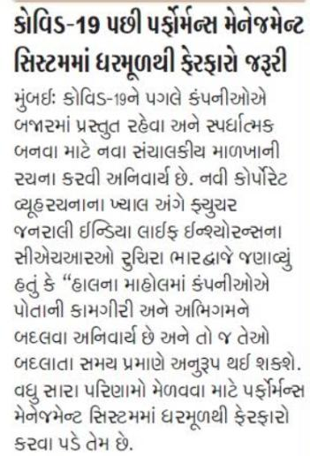

Published Date: | 1 October 2020 | Publication: | Prabhat (Ahmedabad)
Journalist: | Bureau | Page No: | 03

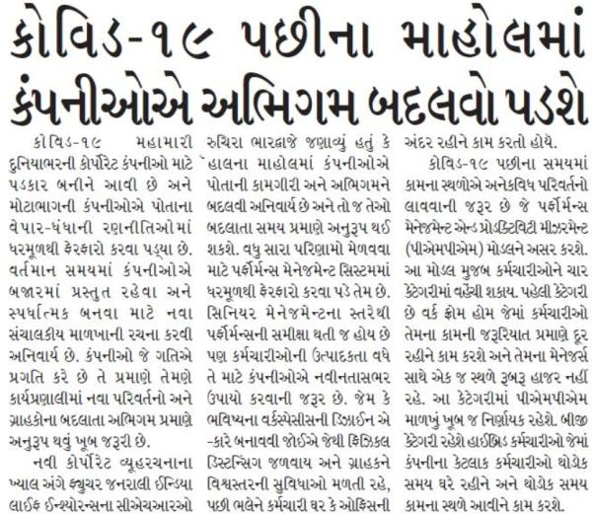

Published Date: | 1 October 2020 | Publication: | Standard Herald (Ahmedabad)
Journalist: | Bureau | Page No: | 07

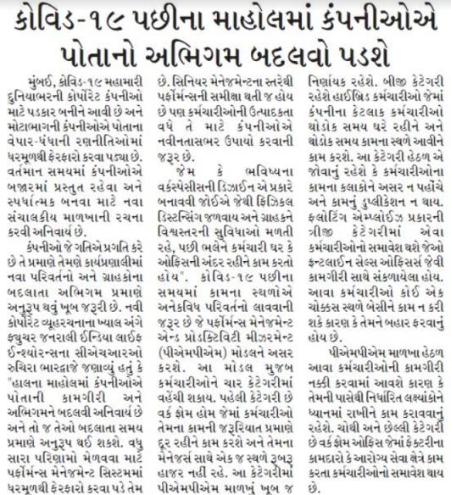

Published Date: | 1 October 2020 | Publication: | Divya Gujarat (Ahmedabad)
Journalist: | Bureau | Page No: | 03

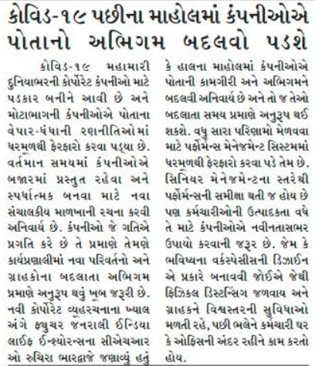

Published Date: | 7 October 2020 | Publication: | NavGujarat Samay (Ahmedabad)
Journalist: | Bureau | Page No: | 08

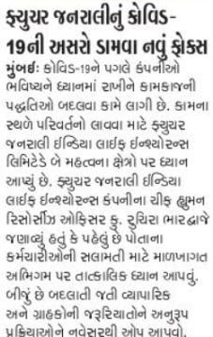

Published Date: | 7 October 2020 | Publication: | Prabhat (Ahmedabad)
Journalist: | Bureau | Page No: | 03

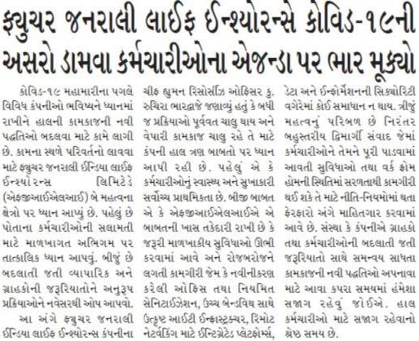

Published Date: | 7 October 2020 | Publication: | Standard Herald (Ahmedabad)
Journalist: | Bureau | Page No: | 07

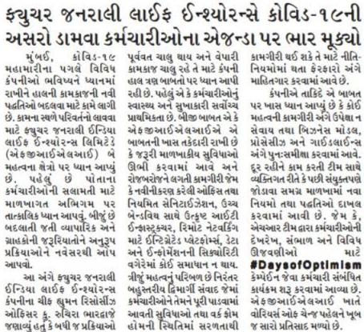

Published Date: | 7 October 2020 | Publication: | Newsline Sidha Samachar (Ahmedabad)
Journalist: | Bureau | Page No: | 02

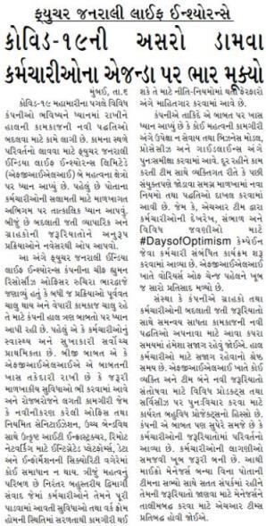

Published Date: | 29 October 2020 | Publication: | Dinakural (Chennai)
Journalist: | Bureau | Page No: | 03

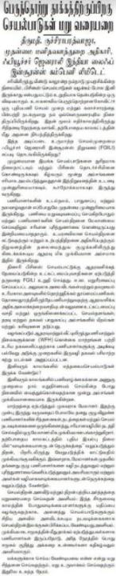

Published Date: | 29 October 2020 | Publication: | Southern Mail (Chennai)
Journalist: | Bureau | Page No: | 05

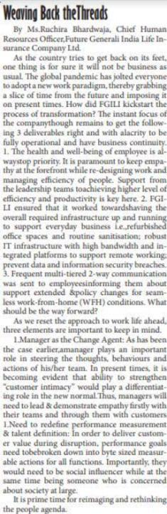

Published Date: | 6 October 2020 | Publication: | Aaj (Lucknow)
Journalist: | Bureau | Page No: | 09

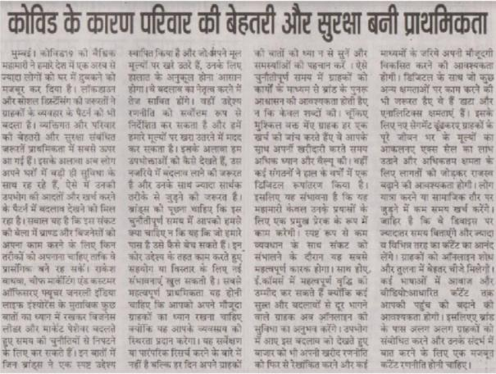

Published Date: | 8 October 2020 | Publication: | Dinakhatir (Chennai)
Journalist: | Bureau | Page No: | 04

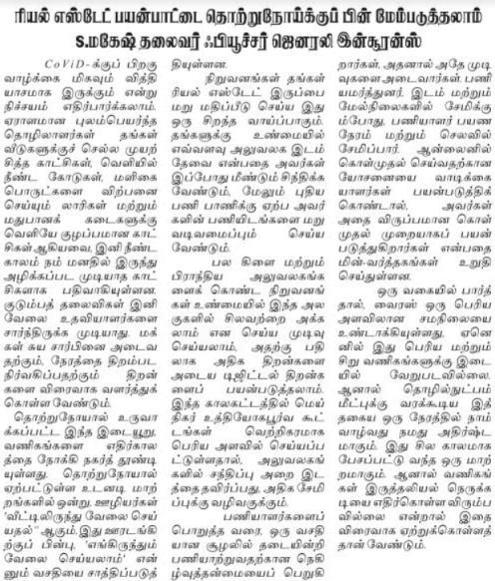

Published Date: | 19 October 2020 | Publication: | Surya (Hyderabad)
Journalist: | Bureau | Page No: | 05

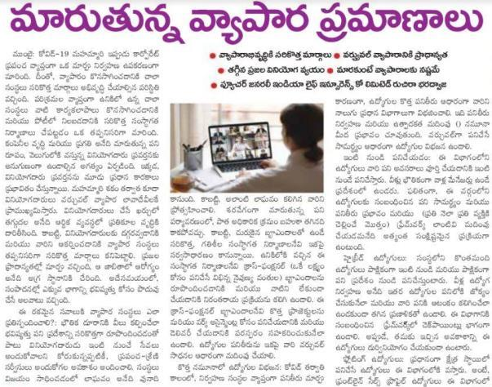

Published Date: | 19 October 2020 | Publication: | Andhra Prabha (Hyderabad)
Journalist: | Bureau | Page No: | 22

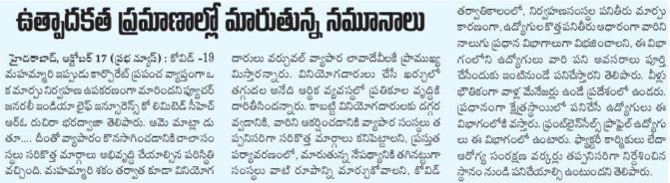

Published Date: | 19 October 2020 | Publication: | Adab Hyderabad (Hyderabad)
Journalist: | Bureau | Page No: | 10

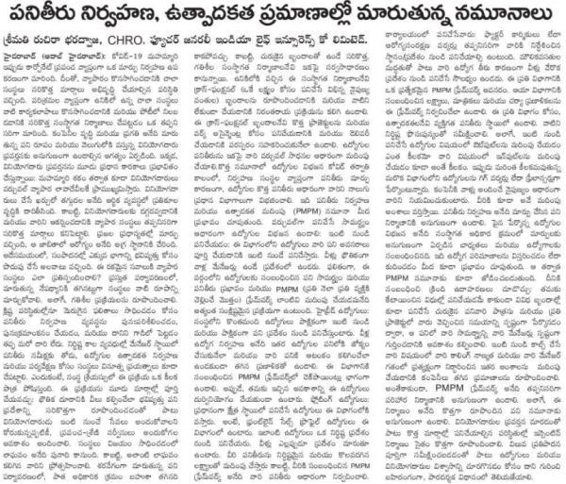

Date | 21 October 2020
Publication | Business Bytes
Headline | Changing paradigms in performance management and productivity
Link | https://buzinessbytes.com/business/changing-paradigms-in-performance-management-and-productivity-measurements/

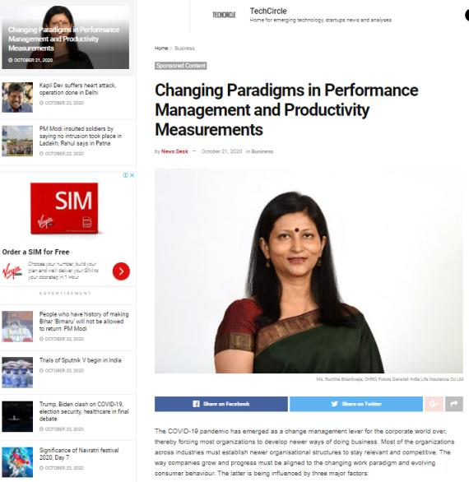

Date | 23 October 2020
Publication | Express Computers
Headline | Video based identification process (VBIP) heralds a quatam shift in customer verification & KYC processes
Link | https://www.expresscomputer.in/news/video-based-identification-process-vbip-heralds-a-quantum-shift-in-customer-verification-kyc-processes/67982/

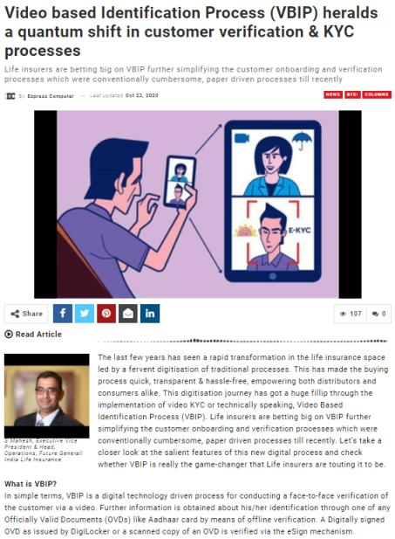

Interview

Date | 19 October 2020
Publication | Adgully
Headline | With the pandemic, customers prefer guaranteed savings plans over ULIPs: Rakesh Wadhwa
Link | https://www.adgully.com/with-the-pandemic-customers-prefer-guaranteed-savings-plans-over-ulips-rakesh-wadhwa-97461.html

Press Release

Date | 7 October 2020
Publication | UNI
Headline | Future Generali India Life Insurance Company Limited introduces Future Generali New Assured Wealth Plan
Link | http://www.uniindia.com/~/future-generali-india-life-insurance-company-limited-introduces-future-generali-new-assured-wealth-plan/Business%20Economy/news/2191083.html

Date | 7 October 2020
Publication | Devdiscourse
Headline | Future Generali India Life Insurance Company Limited introduces Future Generali New Assured Wealth Plan
Link | https://www.devdiscourse.com/article/business/1242831-rising-covid-cases-will-stall-uk-recovery-budget-watchdog-warns

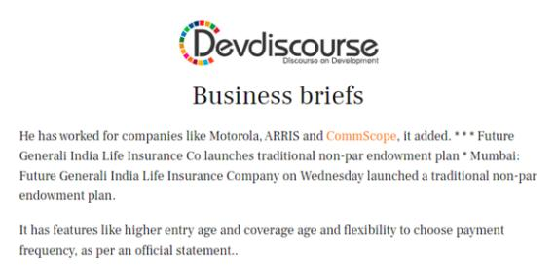

Date | 8 October 2020
Publication | The Financial Express
Headline | Guaranteed Life Insurnce Plan: Future Generali launches New Assured Wealth Plan - Check details
Link | https://www.financialexpress.com/money/insurance/guaranteed-life-insurance-plan-future-generali-launches-new-assured-wealth-plan-check-details/2100781/

Date | 8 October 2020
Publication | News Rediff
Headline | Guaranteed Life Insurnce Plan: Future Generali launches New Assured Wealth Plan - Check details
Link | https://newsrediff.com/guaranteed-life-insurance-plan-future-generali-launches-new-assured-wealth-plan-check-details/#https://www.financialexpress.com/money/insurance/guaranteed-life-insurance-plan-future-generali-launches-new-assured-wealth-plan-check-details/2100781/

Date | 9 October 2020
Publication | Café Mutual
Headline | Future Generali introduces guaranteed return endowment plan
Link | https://cafemutual.com/news/insurance/20418-future-generali-life-introduces-guaranteed-return-endowment-plan

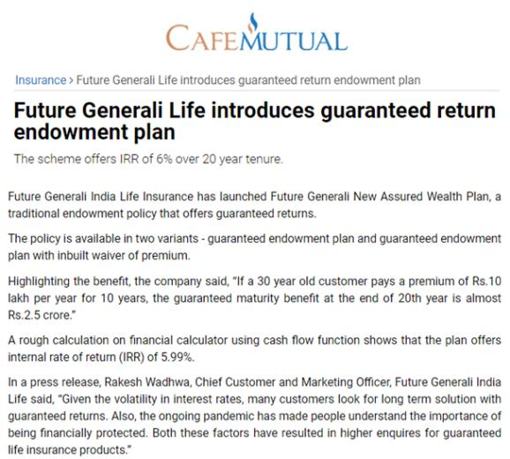

Published Date: | 9 October 2020 | Publication: | Navbharat (Mumbai)
Journalist: | Bureau | Page No: | 04

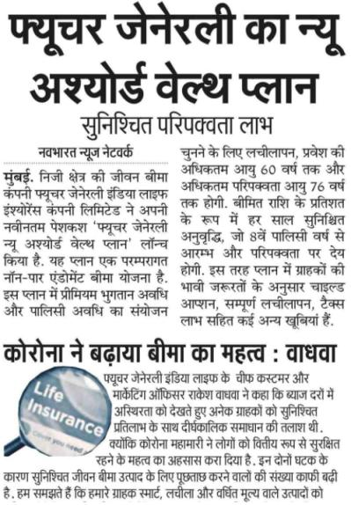

Published Date: | 9 October 2020 | Publication: | Adab Hyderabad (Hyderabad)
Journalist: | Bureau | Page No: | 10

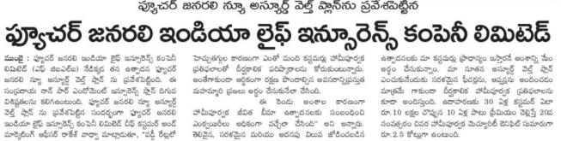

Published Date: | 9 October 2020 | Publication: | Surya (Hyderabad)
Journalist: | Bureau | Page No: | 13

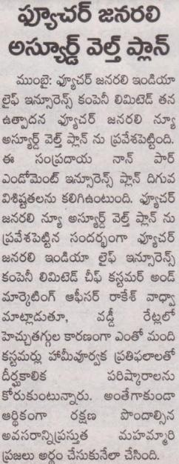

Published Date: | 9 October 2020 | Publication: | Andhra Prabha (Hyderabad)
Journalist: | Bureau | Page No: | 13

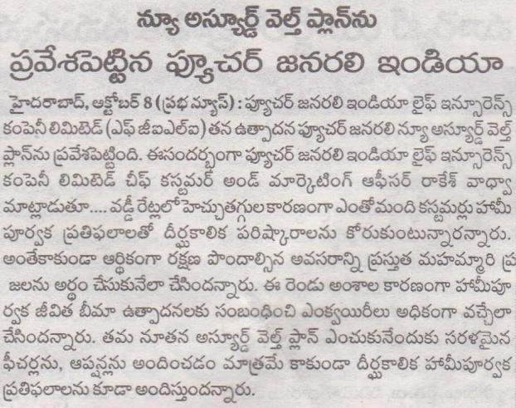

Published Date: | 9 October 2020 | Publication: | Dainik Bhaskar (New Delhi)
Journalist: | Bureau | Page No: | 10

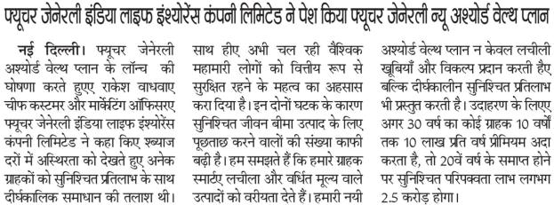

Published Date: | 9 October 2020 | Publication: | Veer Arjun (New Delhi)
Journalist: | Bureau | Page No: | 10

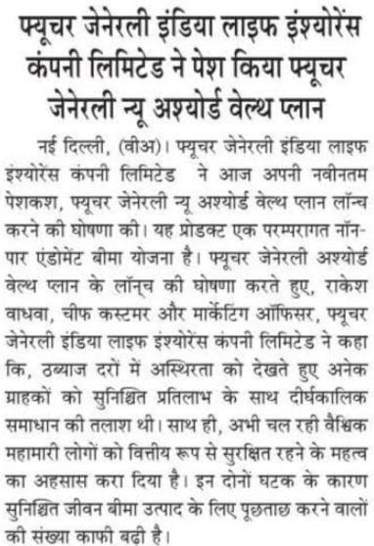

Published Date: | 9 October 2020 | Publication: | Rashtriya Sahara (New Delhi)
Journalist: | Bureau | Page No: | 10

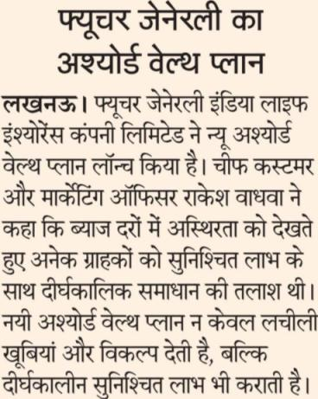

Published Date: | 9 October 2020 | Publication: | NavGujarat Samay (Ahmedabad)
Journalist: | Bureau | Page No: | 08

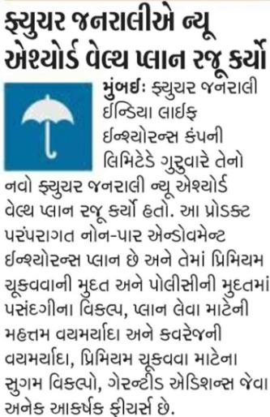

Published Date: | 9 October 2020 | Publication: | Prabhat (Ahmedabad)
Journalist: | Bureau | Page No: | 03

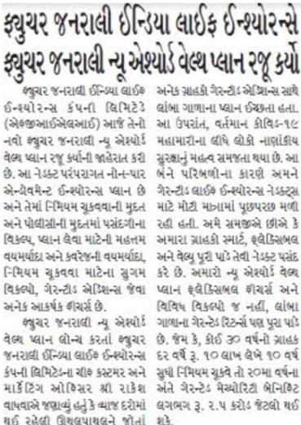

Published Date: | 9 October 2020 | Publication: | Newsline Sidha Samachar (Ahmedabad)
Journalist: | Bureau | Page No: | 09

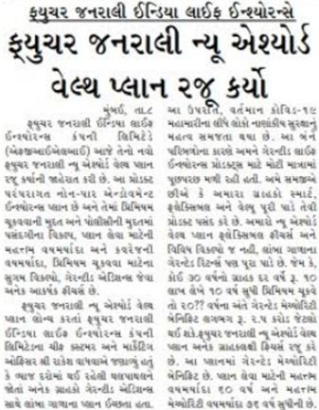

Published Date: | 9 October 2020 | Publication: | Standard Herald (Ahmedabad)
Journalist: | Bureau | Page No: | 07

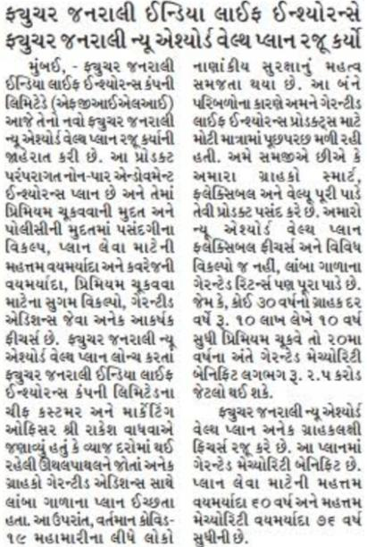

Published Date: | 9 October 2020 | Publication: | Echo of India (Kolkata)
Journalist: | Bureau | Page No: | 08

Published Date: | 9 October 2020 | Publication: | Arthik Lipi (Kolkata)
Journalist: | Bureau | Page No: | 04

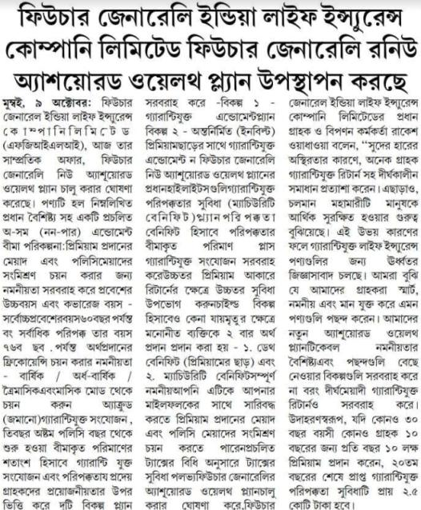

Published Date: | 10 October 2020 | Publication: | Mana Telangana (Hyderabad)
Journalist: | Bureau | Page No: | 09

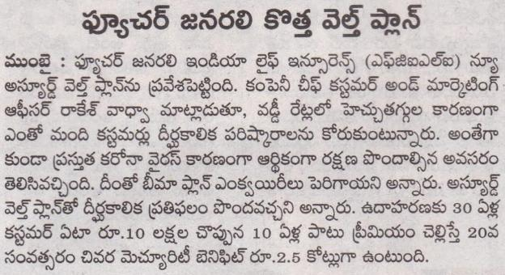

Published Date: | 12 October 2020 | Publication: | Sakshi (Hyderabad)
Journalist: | Bureau | Page No: | 11

Published Date: | 12 October 2020 | Publication: | Aaj Samaj (Delhi)
Journalist: | Bureau | Page No: | 09

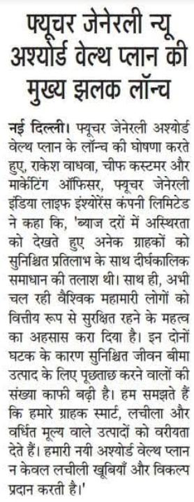

Published Date: | 12 October 2020 | Publication: | Hukumnama Samachar (Jaipur)
Journalist: | Bureau | Page No: | 03

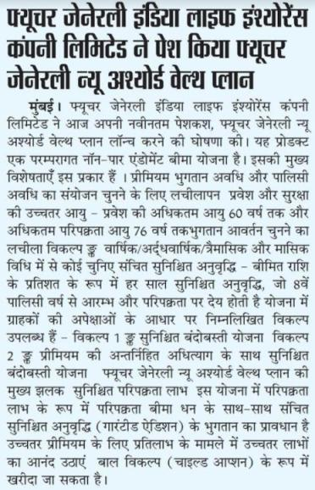

Published Date: | 12 October 2020 | Publication: | Info India (Kolkata)
Journalist: | Bureau | Page No: | 06

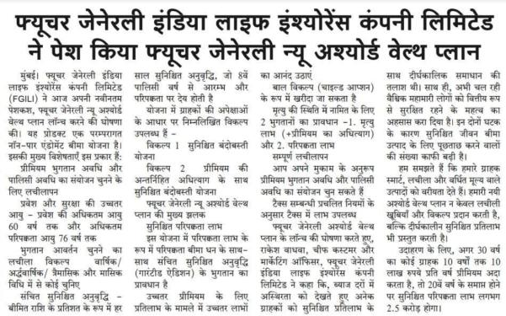

Published Date: | 12 October 2020 | Publication: | ET Wealth (Mumbai, Ahmedabad, Delhi, Kolkata, Bangalore, Chennai & Hyderabad)
Journalist: | Bureau | Page No: | 05

Date | 9 October 2020
Publication | Money Café
Headline | Guranteed Life Insurance Plan: Future Generali launches New Assured Wealth Plan – Check details
Link | https://moneycafe.in/2020/10/08/guaranteed-life-insurance-plan-future-generali-launches-new-assured-wealth-plan-check-details/

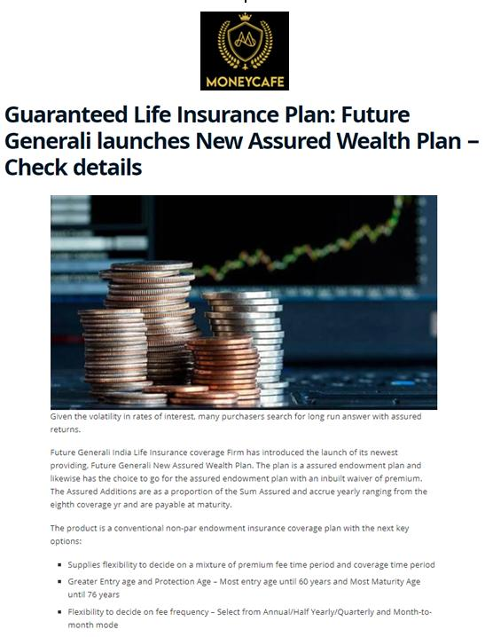

Date | 12 October 2020
Publication | Your Chennai
Headline | Future Generali India Life Insurance Company Limited introduces New Assured Wealth Plan
Link | https://yourchennai.com/2020/10/10/future-generali-india-life-insurance-company-limited-introduces-future-generali-new-assured-wealth-plan/

Published Date: | 12 October 2020 | Publication: | Southern Mail (Chennai)
Journalist: | Bureau | Page No: | 03

Published Date: | 12 October 2020 | Publication: | Dinakural (Chennai)
Journalist: | Bureau | Page No: | 05

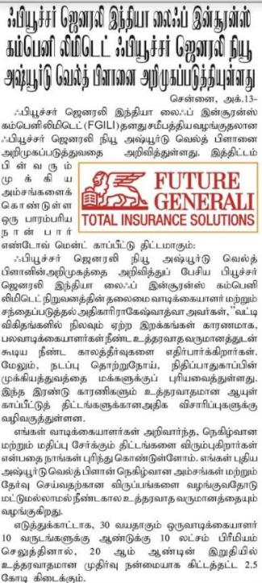

Published Date: | 12 October 2020 | Publication: | Velli Idal (Chennai)
Journalist: | Bureau | Page No: | 03

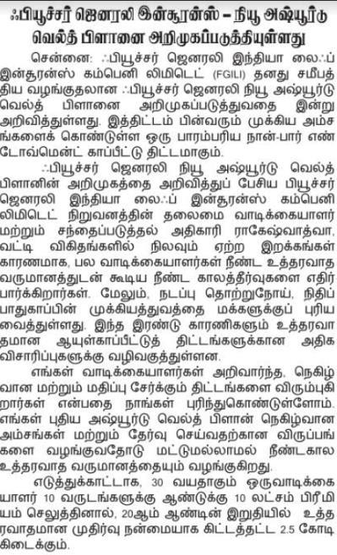

Published Date: | 12 October 2020 | Publication: | Dinakathir (Chennai)
Journalist: | Bureau | Page No: | 02

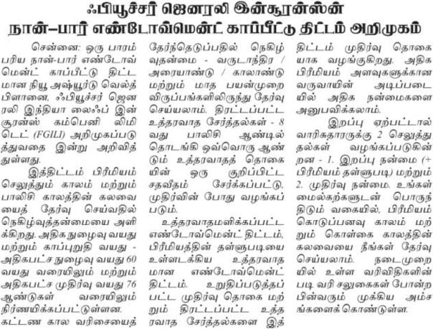

Published Date: | 12 October 2020 | Publication: | Dabang Dunia (Delhi)
Journalist: | Bureau | Page No: | 02

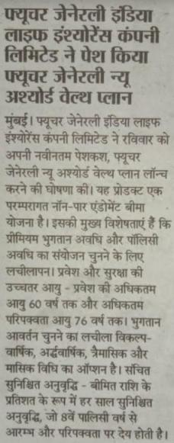

Date | 13 October 2020
Publication | Passionate In Marketing
Headline | Future Generali launches 'New Assured Wealth Plan'
Link | https://www.passionateinmarketing.com/future-generali-launches-new-assured-wealth-plan/

Published Date: | 14 October 2020 | Publication: | Aaj (Lucknow)
Journalist: | Bureau | Page No: | 09

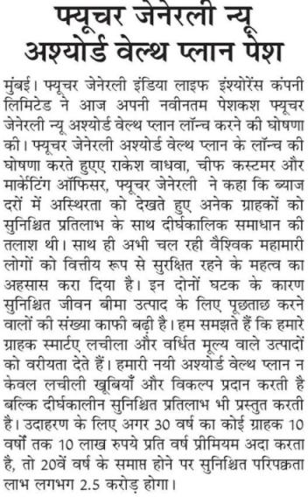

Published Date: | 14 October 2020 | Publication: | Indian Horizon (Delhi)
Journalist: | Bureau | Page No: | 06

Published Date: | 14 October 2020 | Publication: | Virtual Times (Chennai)
Journalist: | Bureau | Page No: | 03

Published Date: | 14 October 2020 | Publication: | Malai Yugam (Chennai)
Journalist: | Bureau | Page No: | 05

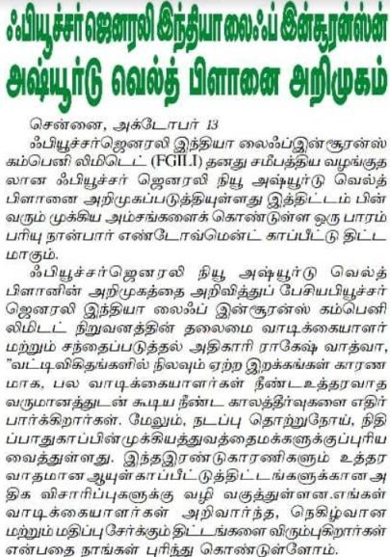

Published Date: | 16 October 2020 | Publication: | The Hans India (Hyderabad)
Journalist: | Bureau | Page No: | 09

Published Date: | 16 October 2020 | Publication: | Prabhu Rashtriya (Kolkata)
Journalist: | Bureau | Page No: | 05

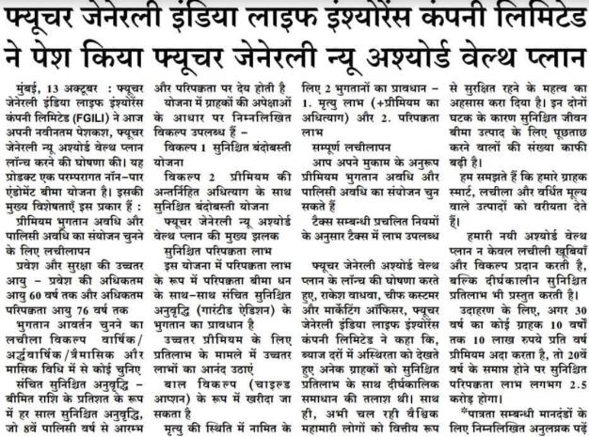

Published Date: | 20 October 2020 | Publication: | Dainik Navjyoti (Jaipur)
Journalist: | Bureau | Page No: | 11

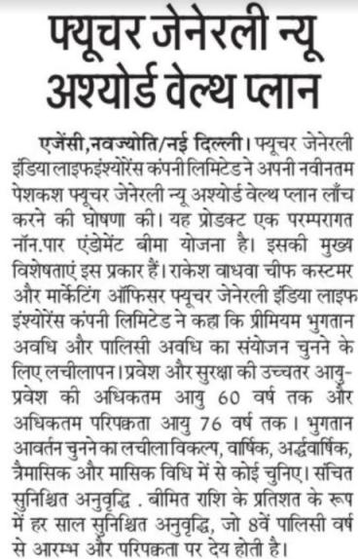

Published Date: | 22 October 2020 | Publication: | Eesanje (Bangalore)
Journalist: | Bureau | Page No: | 04

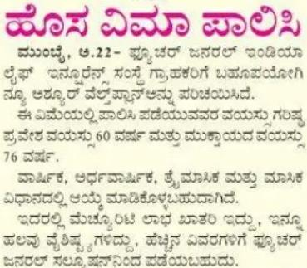

Published Date: | 23 October 2020 | Publication: | Vishwamitra (Kolkata)
Journalist: | Bureau | Page No: | 06

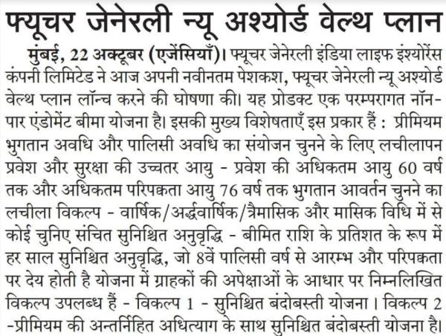

Industry Story

Date | 9 October 2020
Publication | The Financial Express
Headline | RBI MPC meeting live: Shaktikanta Das keeps repo rate unchanged; says real GDP may shrink 9.5% in FY21
Link | https://www.financialexpress.com/economy/rbi-mpc-meeting-live-monetary-credit-policy-repo-rate-accommodative-stance-shaktikanta-das-rbi-governor/2101392/

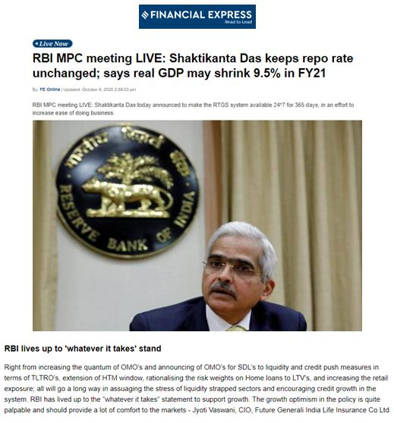

Date | 9 October 2020
Publication | The Financial Express
Headline | Experts views on RBI Monetary Policy – October 2020
Link | http://www.equitybulls.com/admin/news2006/news_det.asp?id=275082

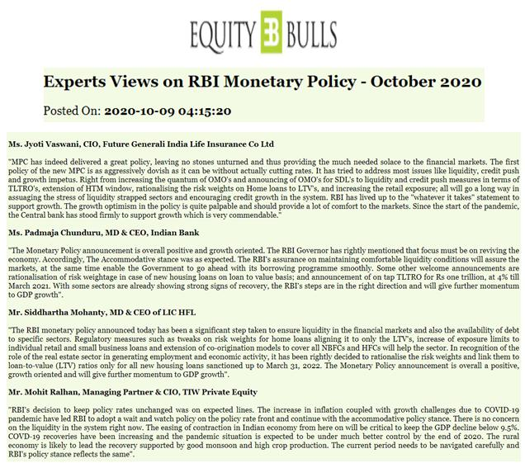

Published Date: | October 2020 | Publication: | Banking Frontiers (National)
Journalist: | Bureau | Page No: | 20-26

